Ex no: 12
Improvement in the web application code after
testing and customer feedback

Aim:
To get customer feedbacks and making changes in the applications.

Feedbacks:

1.Form format on Hotel Booking , Transport Booking , Tour Booking
2.Filtering
3.Overall Flow of the Application

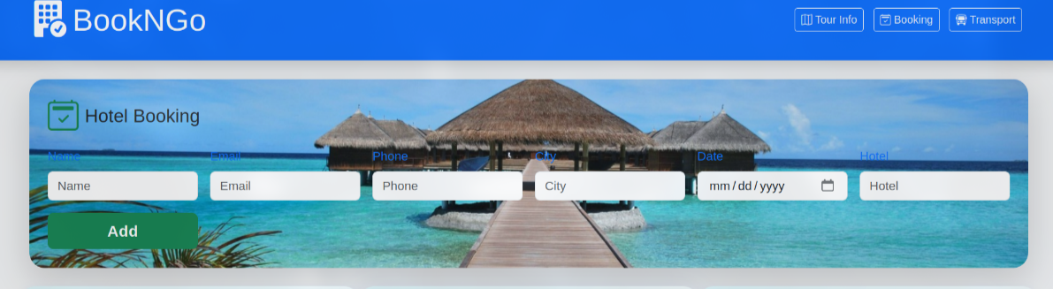
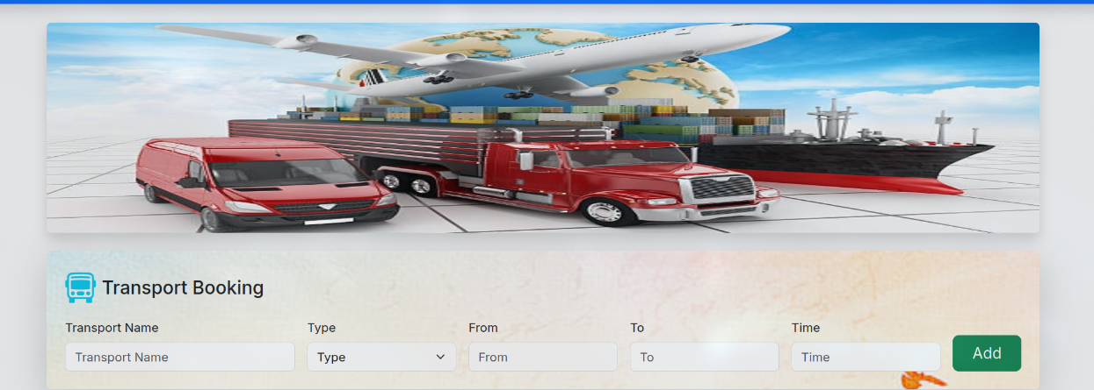
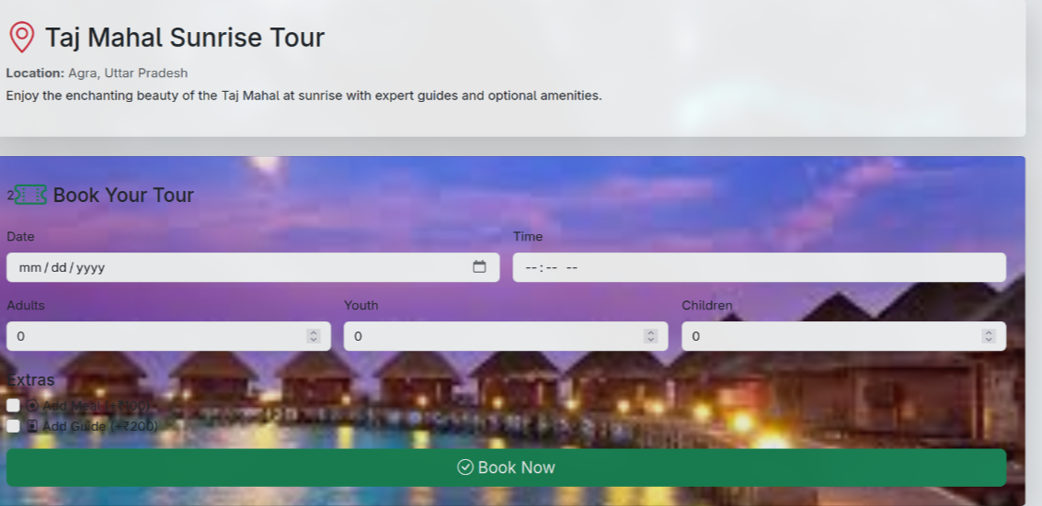
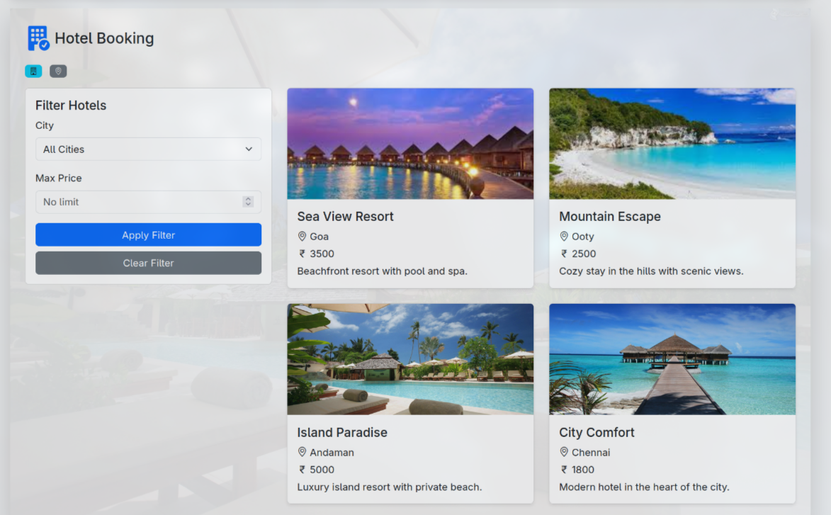
Fixes:
1.Used filters based on cities without actually giving data

